**HEATING CYCLE 1**

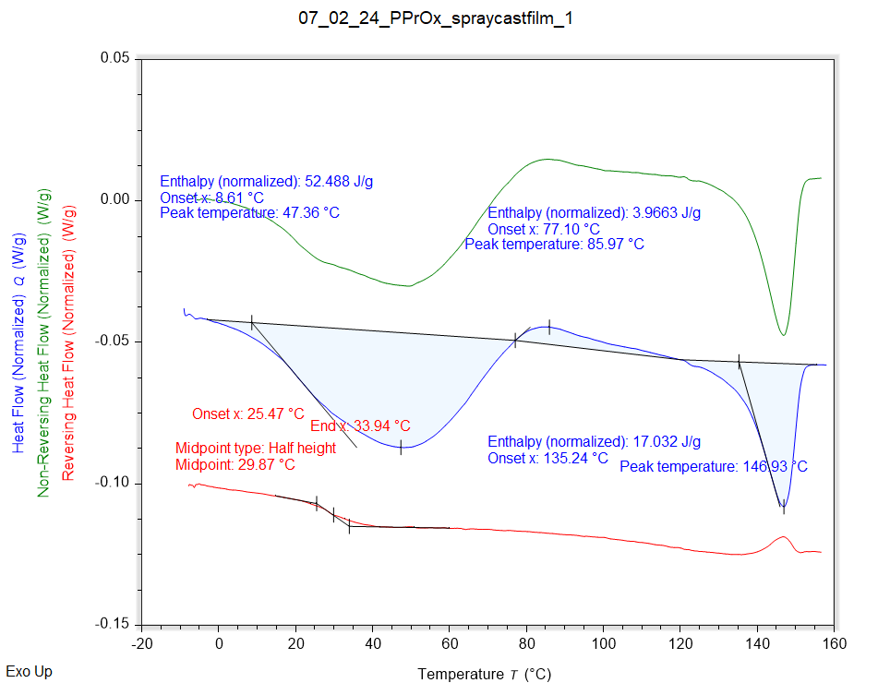

|  |  |
| --- | --- |
| Solvent HC1 | Peak Onset |
|  | 8.610 °C |

|  |  |  |  |
| --- | --- | --- | --- |
| Recrystallisation HC1 | Peak Onset | Peak Location | Peak Location |
|  | 77.097 °C | 85.974 °C | 85.974 °C |

|  |  |  |  |
| --- | --- | --- | --- |
| Melting HC1 | Peak Onset | Peak Location | Enthalpy |
|  | 135.235 °C | 146.927 °C | 17.032 J/g |

|  |  |
| --- | --- |
| Tg HC1 | Onset |
|  | 25.475 °C |

**HEATING CYCLE 2**

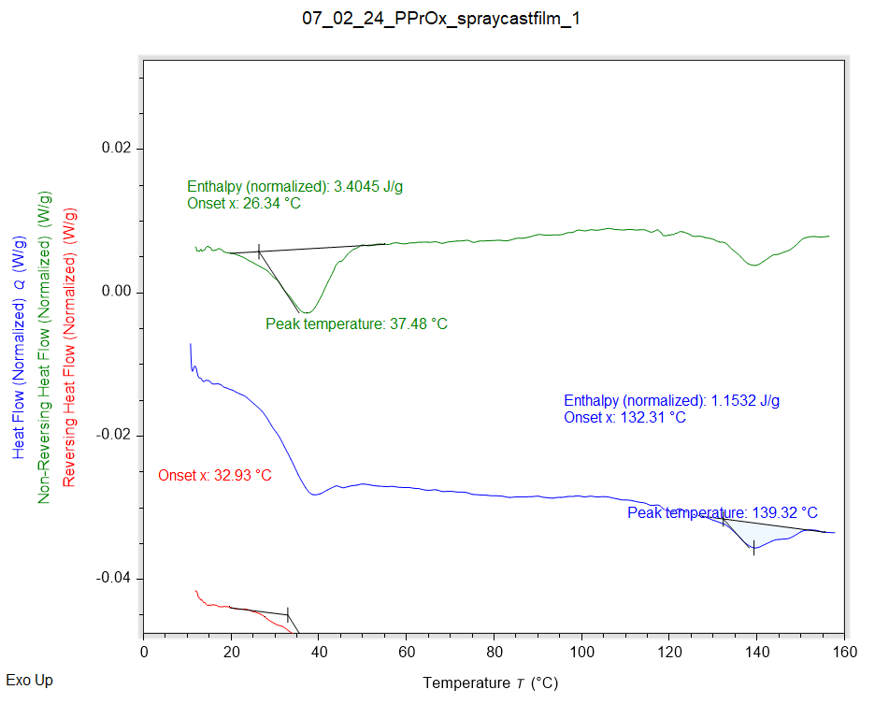

|  |  |  |  |  |  |
| --- | --- | --- | --- | --- | --- |
| Solvent HC1 | Peak Onset | Peak Location | Enthalpy | Extra | Extra2 |
|  | 26.342 °C | 37.480 °C | 3.4045 J/g | 3.4045 J/g | 3.4045 J/g |

|  |  |
| --- | --- |
| Melting HC1 | Enthalpy |
|  | 1.1600 J/g |

|  |  |  |
| --- | --- | --- |
| Tg HC1 | Onset | Midpoint |
|  | 32.932 °C | 39.680 °C |

**HEATING CYCLE 3**

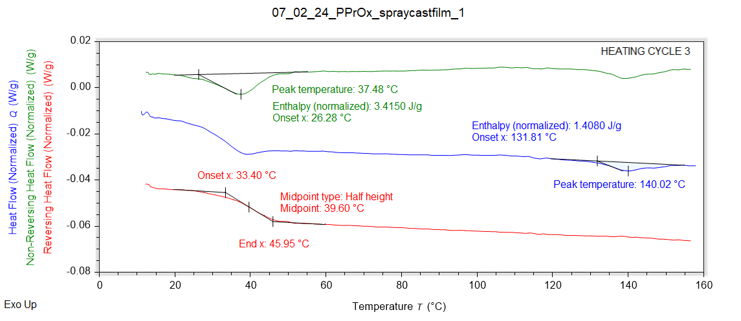

|  |  |  |  |  |
| --- | --- | --- | --- | --- |
| Solvent HC1 | Peak Onset | Peak Location | Enthalpy | Extra |
|  | 26.278 °C | 37.478 °C | 3.4150 J/g | 3.4150 J/g |

|  |  |
| --- | --- |
| Melting HC1 | Peak Onset |
|  | 131.809 °C |

|  |  |  |
| --- | --- | --- |
| Tg HC1 | Onset | Midpoint |
|  | 33.397 °C | 39.602 °C |